PROJECT PLANNER

 800.928.8160
 www.ClarityProjects.com

Better Systems. Better Sales. TM
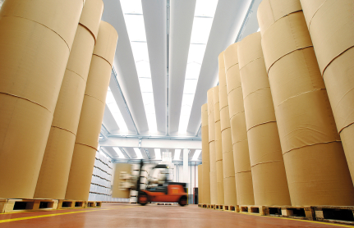
IT’S ALL IN THE DETAILS
We’re committed to meeting the quality standards you uphold for your organization. Working out the kinks ahead of time enables us to deliver a highly effective solution on time and on budget.

Let’s get started.

Project Development Lifecycle
Your project will go through multiple interactive phases over the course of development, during which time your constructive feedback will be welcome and necessary for successful completion. We’ve put together a diagram illustrating these steps to help you know what to expect and stay excited about moving forward.

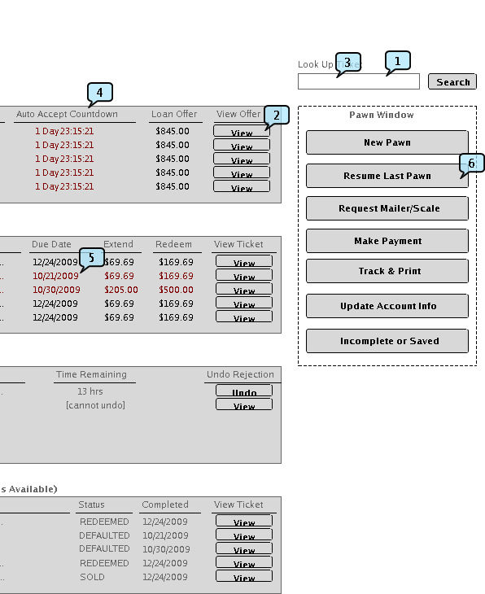
FUNCTIONAL REQUIREMENTS
During the requirements process documentation is created to track decisions made regarding workflows and scope of the project. Wireframes, or sketches and notes of user screens such as the registration screen on the right, are created to expose potential misunderstandings and to visualize screens quickly without the expense of traditional Photoshop mockups. Small proof of concept projects are coded if necessary to verify any complex functionality or questions regarding technical limits, such as, “can we print a PDF document to a special paper size from a web page?”
The requirements process is highly interactive and relies on the client being available to help conceptualize and document the project. It is not unusual for this process to take longer than the actual coding of a project.
DEVELOPMENT
During development the code is written and tested. Periodic development releases are published to a server so the client may walk through the completed functionality and verify it is meeting expectations. In general, backend workflow and database code is written and tested prior to any associated screens, so there is an initial period where code is being written but no visual progress is available.
Workflows and database code are thoroughly tested using programmatic simulations so most bugs are worked out before work on any screens starts. This approach helps us respond faster to client feedback during testing because our team can focus on making changes to screens rather than being sidetracked by bug fixes.

QUALITY ASSURANCE & RELEASE
Quality assurance is the final iteration of development and client feedback once the bulk of coding and testing has been completed. During this process we make last minute grammatical corrections, minor updates to code, and configuration preparations for launch. Once the client is satisfied and signs off on the launch, the project is published to a live server and opens for business.
Our team closely monitors the project and stays in constant communication with the client for several weeks after the initial launch. This ensures a smooth transition and gives the client an opportunity to continue to make updates based on user feedback.
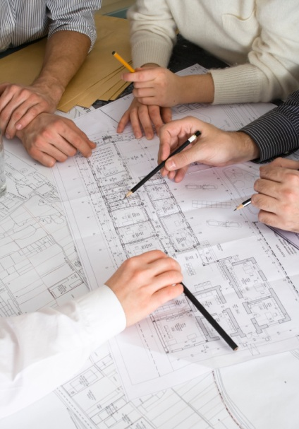
PROJECT SCOPE

COMPANY CONTACT INFORMATION
- Official company name:
- Company full address:
- Main contact for the project (name and title):
- Final decision maker for the project:
- Phone:
- Email:
- Current Website Address (if applicable):

GENERAL
- Please provide us with a name and brief description for your project.
- Do you have a budget set aside for this project? If so, what is your range?
- What are your objectives for this project?
- What are the long term goals for this project?
- At what stage is this project? Are or have there been other development companies involved?
- Please specify the estimated number of unique content pages you expect in your site if applicable?
- Please specify the estimated number of unique screens you expect in your application if applicable?
- How often do you anticipate updating content on your website or database?
- Who will be responsible for updating this content and the overall management of the site?
- What is the availability of text and multimedia content for your project? For example, has copy been written and do you have existing images available?
- What multimedia elements do you want for your project, such as streaming video, flash, etc.?

TIMELINE
- What kind of timeline do you have for this project?
- What are the driving factors behind your timeline?
- Which of these factors do you have control over and which are external constraints?
- What kind of resources (who and how many hours) do you have available for the planning process, feedback during development, and testing prior to launch?
- Do you have any specific requirements for testing, such as regulatory compliance or company policies?

MARKETING
- Briefly, what are your short-term marketing goals (in the next 1-2 years)?
- How do you anticipate this new web site helping to reach those goals?
- What do you feel is your number one existing problem?
- Do you have an advertising agency or public relations firm? If so, will they be involved in this project?
- How do you intend to advertise or drive traffic?
- Do you plan to incorporate affiliate advertising in your project?
- Who are your top competitors and what do you like dislike about their websites or other systems?

AUDIENCE & USERS
- List the various types of people who will be using your project and their different roles. For example: customers, vendors, employees, managers, etc.
- What do you feel are the three most important needs of your target audience as it relates to your business (for instance: getting an insurance quote, buying a product …)?
- How many people do you expect to use your project? For example, 1,000 people at any given time and 30,000 visitors per month.
- At what times of the day and year (seasonal) do you expect your users to access the site? What are the peak times you expect?
- Is this project subject to accessibility requirements, such as Section 508?
- Will you need the ability to accept foreign (non U.S.) currencies?
- Will you need the ability to have multiple languages?

PERCEPTION AND DESIGN
- Use three adjectives to describe how the user should perceive the finished project. (examples: conservative, progressive, friendly, formal, casual, serious, energetic, humorous, professional …)
- a.
- b.
- c.
- Is this different than current image perception (if applicable)?
- Have you had any challenges in the past with image perception (for example: market research revealed that the current color scheme did not appeal to the target market …)?
- Describe any visual elements or styles that can be utilized from existing marketing materials or collateral (if applicable).
- Is there a current corporate style guide that will be used? No If not, are you considering the creation of a corporate style guide, identity or logo?
- How is your company currently perceived? Do you wish to carry the same kind of message through this new project?
- List any web sites you find compelling. What do you find most interesting about these sites?
- List web sites of competitors and briefly describe what you like and dislike about them.
- Are you interested in utilizing any Flash animation or other multimedia (for example: video) on the site?

WORKFLOW
- Describe the lifecycle and scenarios each type of user will encounter. Consider all of the possible tasks each user will need to accomplish, what information they will need to provide, and the results they will expect from each operation. For example, a customer may need to register, receive an approval code via email, sign in with the code, set up their profile, and then perform other actions. Please be as specific as possible.
- Optionally sketch out your vision for what your customers will see as they use your website or application.

TECHNICAL CONSTRAINTS
- Do you have a domain name already registered or a desired domain name? If already registered, with which company is your domain registered?
- Do you have a current hosting provider or any specific plans for hosting? If so, who is your current hosting provider?
- Is there specific technology or any existing software you are already using related to this project? For example, an existing project written in PHP, or an accounting package with which you want your new project integrated.
- Is there existing information (e.g. database records, photos in a printed magazine, stock prices) you need imported into your new project either on a one time or recurring basis?
- Does your project need to export data to any external sources or provide data for download by users? If so, in what format(s)?
- Which browsers and platforms will your users access your website and/or application from?
- What kind of special client side functionality do you require for your users, such as modal popups, no visible post backs or screen flicker, etc.? Can you point us to examples?

SECURITY, AUTHENTICATION, VALIDATION
- Do you have any specific security requirements, such as identity verification, barcode scanning, or corporate password policies?
- Are you subject to any security laws or regulations, such as PCI compliance?
- Do you currently have any secure SSL or code signing certificates?
- Are there any local or federal laws your project must adhere to regarding record keeping, audit of user activities, etc.?
- How will your users be created? Will they register individually or be added by other users? Is there an approval process?
- How will your users log in to the system?
- Do you have requirements for validating user input and internally generated data, such as specific phone number formats, specially formatted order numbers, etc.?

PLEASE COMPLETE THIS SECTION IF YOU REQUIRE ECOMMERCE FUNCTIONALITY

PAYMENT & E-COMMERCE
- Will you be accepting payments?
- Are you already signed up with a payment provider? (This may be different than your bank.) If so, are you aware there are generally variable costs associated with accepting online payments?
- Please specify the estimated number of unique product pages you expect in your site if applicable? Please specify the number of product options, accessories, and/or unique filters you expect on your site?

SHOPPING CART FUNCTIONALITY
- Do you have any examples of websites that have a similar style or function to what you envision for your website? Please list:
- Please describe in detail the steps a user would take to shop on your new website (example: Click on product category, click on sub category, see product thumbnail images, click on thumbnail for more product info, add product to cart, go to checkout, fill in requested information … etc.):
- Do you want your customers to have to login to shop, check out, or view their account?
- If you would like customers to have the ability to create an account, would you like them to be able to choose their own password or to generate an automatic password for them (a "password reminder" would be included)?
- Do you want customers to have the ability to save their address, etc. information and login to their account before shopping to have that information pre-filled in (example: Repeat customers)?
- If you would like your customers to have the ability to login to their account, would you like them to also have the ability to view past orders?
- Do you need customers to have the ability to track or view the status of their orders?
- Do you need your customers to have the ability to have a "wish list" (example: Like on Amazon.com)?
- Do you need to have featured products or best sellers listed on your front page?
- Do you need suggested additional products (cross-selling/up-selling) to show up when a customer places an item in their cart?
- Do you need the ability to offer coupons or discounts?
- Do you need customers to have the ability to subscribe/sign-up for a newsletter, coupon/discounts, etc.?
- Do you need customers to be able to send a product page to a friend (example: "tell a friend" function)?
- Would you like customers to have the ability to review products?
- Would you like to have the ability to run an affiliate program?

SEARCH
- Do you want advanced features like auto-complete, filtering, sorting, etc.?
- How would you like your customers to be able to search for products (ex. title, description, category, SKU, price etc.)?

PRODUCT STRUCTURE
- Approximately how many products do you have?
- Do you currently have your products in a database or Excel file?
- Do you expect to add many products over time?
- Will your products be separated into categories (and subcategories)? If so, can you list the categories/subcategories?
- Can a product belong to more than one category?
- Do you expect to add many products over time?
- What are your product options (ex. color, size, etc.)?
- Do your products have long descriptions?
- Do the products need to display more than one image?
- Are any of your products downloadable (examples: e-books, mp3s)?

SHIPPING/TAX
- Please tell us how you will be shipping your products (examples: UPS, by weight, by order total):
- Do you need to mark up your shipping at all (example: Add a handling charge per item)?
- Do you need the ability to add more than one state tax?
- Are you planning to ship internationally?

REPORTS
- List the type and purpose of any reports you expect to have for the project.
- Do you require automated reporting, such as daily reports emailed to specific users?
- Do these reports include charts, graphics, dashboards, or drilldowns?
- Do they require special export features such as Excel, PDF, etc.?
- Do you have specific printing requirements, such as using DYMO label printers?

SALES/ANALYSIS (Will you need any of the following Comprehensive statistics)
- Number of orders
- Number of customers
- Product views
- Category views
- Sales by product / best sellers
- Total sales
- Searchable order data
- Order data is easy to print
- Printable shipping labels
- Yes, all but printable shipping labels

PLEASE COMPLETE THIS SECTION IF YOU WANT DETAILED BRANDING GUIDELINES

BRANDING OVERVIEW
An organization’s brand communicates everything; what they do, how they’re unique, and so on. It’s a solid fact that customers make decisions based on the emotional alignment of a brand, to who they are as a person. It’s our goal, to give your organization a brand with just this type of alignment. But, in order to do so we need information. In this section, you will find a basic questionnaire and a detailed questionnaire –Please answer each with brutal honesty, and don’t hesitate to add anything beyond what we’ve asked. If you have time to complete the detailed questionnaire it will further solidify our understanding of your brand. It’s also an effective exercise to have multiple different people within your organization complete this survey.
Important: - use these links to download branding guideline samples: Ex. 1, Ex. 2, Ex. 3, Ex. 4, Ex. 5, Ex. 6.

BASIC BRANDING QUESTIONNAIRE
- Please describe your organization if it was a person. Tell us things like: age, clothing, type of car, lifestyle, man or woman, and anything else you think is important.
- Who is your target audience? Please describe demographics such as age range, lifestyles, buying behavior, attitudes, and so on.
- How do your customers perceive your organization? If there’s any primary data on this, please note it here.
- In an ideal world, how would your customers perceive your organization?
- What makes your organization and its products/services different from similar offerings in the marketplace?
- What is the company’s brand equity? For example, is it associated with a person of idea? Is it famous for an ad campaign or tag line?
- How do you currently communicate this difference to customers?
- What is the greatest hurdle in trying to communicate this?
- Who are your top competitors? Please list their names and URL’s.
- Please describe the weaknesses of your current branding/ identity? The more details here, the better.
- Is there branding, from other organizations, you find compelling? If so, please list the organizations.
- What branding have you seen that just rubs you the wrong way? Please list the organizations.
- After we create new branding, do you need us to help with the implementation? For example, putting the new logo up on your website or updating collateral.

DETAILED BRANDING QUESTIONNAIRE

GENERAL QUESTIONS
- What is your business?

  - Example: We make shoes. / We teach Kung-Fu.
  - Why ask: Understand what the company does officially, later on in the questionnaire it will be interesting to see what the real product/service is.

- How old is your company?

  - Example: More than 50 years old. / Started up just 9 month ago.
  - Why ask: It's for general orientation. The answer may also give you an idea.

- Size of your company?

  - Example: 200 employees in 4 countries. / Just me and my brother.
  - Why ask: The answer may give you an idea and gives a general understanding for the weight of the brand.

- Your business in one sentence?

  - Example: We make great hiking shoes for families and professional hikers. / We will teach you how to defend yourself with anything that you find.
  - Why ask: We are getting closer to the nature of the business, but we're not done.

- Your business in two words?

  - Example: Hiking shoes.
  - Why ask: That's more like it.

- Your business in one word?

  - Example: Hiking
  - Why ask: See how different the real nature of the business from the official one in question 1.

IN DEPTH

- How did the company start?

  - Example: The owner was a scout in WW2 in the Austrian Alps and he had to go up hill 5 kilometers daily. He perfected the army shoes & after the war he founded the company.
  - Why ask: Such stories will give you amazing insight to the company and may give you an idea.

- Is there a story that is unique to your company?

  - Example: Actually Edmund Hillary wore a shoe the owner made in 1953 when conquering the Mount Everest.
  - Why ask: It tells you what the company is proud of, therefore you can build on this in your logo.

- If you company/brand was a person who would it be?

  - Example: Columbus, because he was an adventurer always looking for new ways of doing the same thing.
  - Why ask: A brand is perceived by consumers like a person. You trust them, you communicate with them through advertising and purchase, you get disappointed by them, etc. The identity you're designing is the face of that person.

- If your company/brand was an object what would it be?

  - Example: I don't know, maybe a compass…
  - Why ask: Ideas, ideas, ideas, you can't have enough of them.

- If your company/brand was an animal which one would it be?

  - Example: Lion
  - Why ask: This is a conversation starter. If elephant, you may ask why to find out more that might give you an idea.

- Is there an important object, building or person for your business?

  - Example: Our original factory in Graz is painted bright pink and people always joke about it.
  - Why ask: You are looking for existing imagery that the brand is already known for, you may just need to make an icon out of it.

- What do your wear to work?

  - Example: Jeans and t-shirt / Traditional business professional.
  - Why ask: The answer sets the style for the identity.

THE MARKET

- How does the market see your company today?

  - Example: They think we're a well-established company with good products.
  - Why ask: Must know what the current perception is to make sure the new identity doesn't depart too much from it, so that the brands keeps the trust of existing customers.

- What aspect of your image needs improvement?

  - Example: People think we are old school. / We are seen to be semi-professional.
  - Why ask: This is the bad perception, that keeps the business from growing. This is what you have to fight with the new identity.

- How do you want your image to be seen in 2 years?

  - Example: We want to be seen as a company with traditional values but using the latest technology and materials.
  - Why ask: This is what you have to portray in your new identity to serve you.

- Who are your competitors?

  - Example: CAT, Timberland and other smaller companies.
  - Why ask: The identity has to be easily identifiable and it has to be unique. It's essential to research the competition.

- How are they better/worse than your product/service?

  - Example: CAT and Timberland has strong brands. We are less well known. CAT is masculine, we are not, but want to be. Timberland has a very natural feel to it. We want to have that too. We have a bigger history and we are more serious about our product than these two brands.
  - Why ask: You have to identify your brand's strength and weaknesses and build on them.

THE TARGET

- Who is your customer?

  - Example: Mainly hobby hikers and a few professionals as well.
  - Why ask: You need to know who you are talking to. If you're talking to kids you need to speak a different visual language than if you're talking to bankers.

- If your customer was a cartoon character who would it be?

  - Example: Bugs Bunny / Buzz Light-year
  - Why ask: Cartoon characters have exaggerated characteristics. Identifying the stereotype of your customer is easier through this exercise.

CURRENT IDENTITY

- Do you have an identity?

  - Example: Yes / No
  - Why ask: You have to create a visual continuity, unless a sudden change is required because of a strong negative association with the old identity.

- What do you like about it and what do you not like about it?

  - Example: I like the colors, but the Boy Scout around the fire is not serious or trendy.
  - Why ask: Obviously you may consider keeping what you like and stay away from what you don’t like, unless you have strong reasoning for doing otherwise.

- What are your company colors? Please specify any variations for specific sub-divisions or groups within the company. Please identify the actual color id.

  - Example: GOLD: PMS 124, PURPLE: PMS 269, PURPLE-GREY: PMS 5265
  - Why ask: This is key to matching your existing branding efforts with the new branding efforts. In some cases you may not have this information or may want to effectively “start over” on the identity and branding – if that is the case, you can ignore this question.

- What are the company fonts?

  - Example: Tahoma and Arial
  - Why ask: If you have specific fonts that you use within the company’s branding efforts, let us know what they are. We will leverage this information to get a head start on your branding efforts.

- Please provide any existing marketing and branding collateral that has logos, imagery, or other branding related identity information that you want us to capture and use.

  - Example: Send images of customers using the product in the field, service reps on the phone working, or possibly marketing material that truly captures the essence of your organization.
  - Why ask: This will again help our team get a clear visual understanding of your organization’s values and help establish specific areas of emphasis.

w: www.ClarityProjects.com
e: info@Clarity-Ventures.com
p: 800.928.8160
Better Systems. Better Sales. TM
 www.ClarityProjects.com

 800.928.8160

